EXP NO 6: CREATE A SIMPLE CLOUD SOFTWARE APPLICATION FOR PRODUCT SELLING USING ANY CLOUD SERVICE PROVIDER TO DEMONSTRATE SAAS.
AIM:
To create a simple cloud software application for product selling using any cloud service provider to demonstrate saas.
PROCEDURE:
step1: Go to zoho.com.
step 2: Log into the zoho.com.
step 3: Select one application step.
Step 4: Enter application name as product selling.
step 5: Created new application as product selling.
step 6: Select one form step.
step 7: The software has been created.

Output:
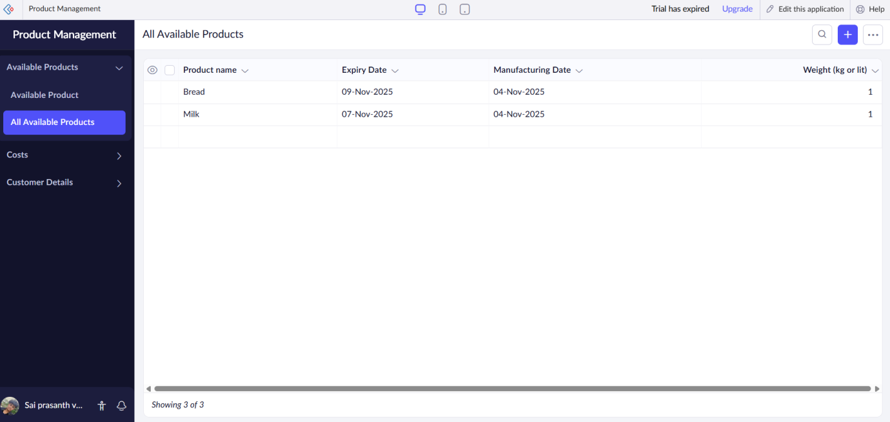

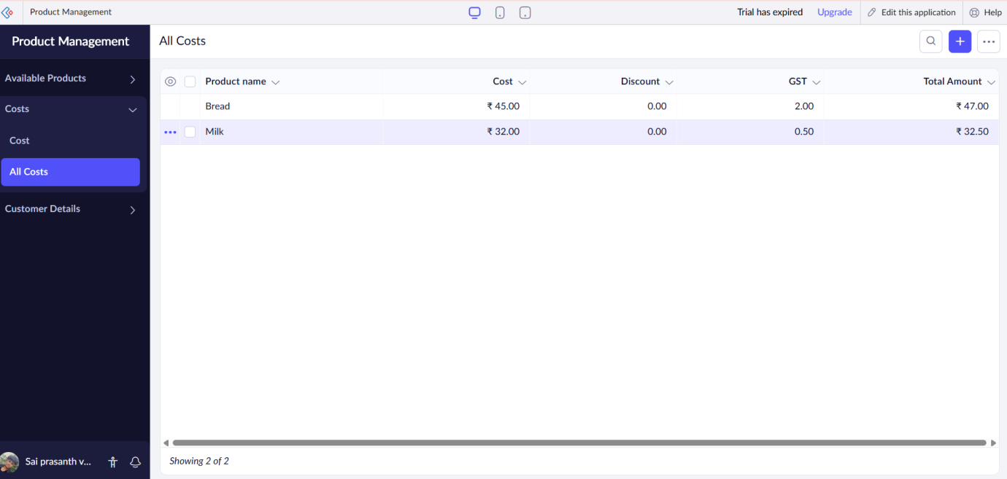
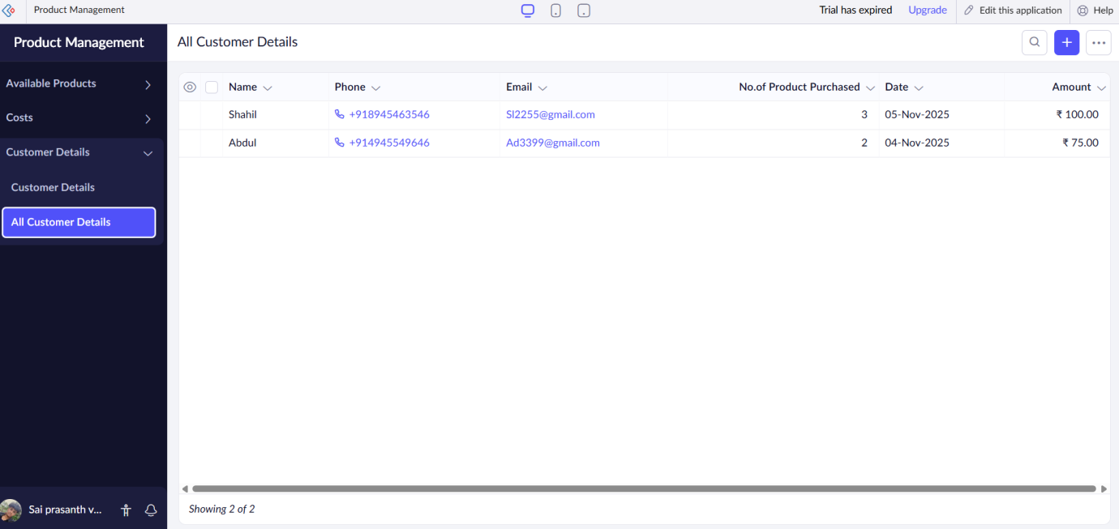

Result:
A simple cloud software application for product selling using any cloud service provider to demonstrate saas has been implemented suceessfully.

